SADDLEWOOD MEWS, DARLINGTON

Dear Sir or Madam

Thank you for your enquiry regarding accommodation at Saddlewood Mews.

Subject to availability we are able to offer furnished accommodation to employees of County Durham & Darlington NHS Foundation Trust within Elm House, Cedar House, Willow House or Westlea House adjacent to Darlington Memorial Hospital.
The apartments have been refurbished to a high standard and are offered as a 2 bedroom apartment or a room only basis (i.e. two persons sharing one apartment).
To assist us in making appropriate offers to individuals, please complete and return the attached application form.
Should you have any questions or further clarification please contact the Bespoke Lettings Team:
Phone: 0300 111 1000
Please return application to:
Scanned and e-mailed to Manisha.Sharma@thirteengroup.co.uk

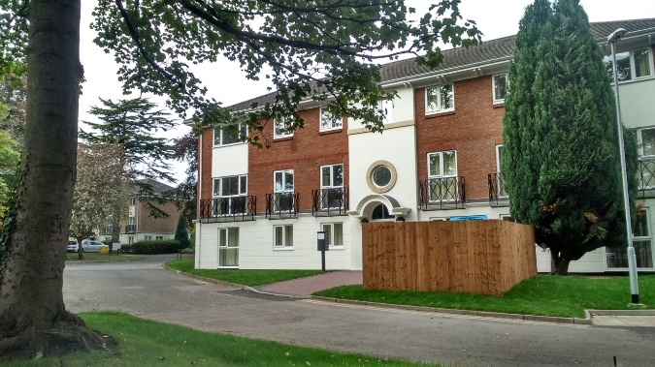
Westlea House

Accommodation Information

- New double glazed windows
- Gas central heating and hot water with boiler in each apartment
- New kitchens, bathrooms and internal fixtures & fittings.
- New external doors and door entry systems.
- Furnished accommodation to include carpets, curtains or blinds, sofa/chairs, dining table, coffee table, fridge/freezer, cooker, washer/drier, bed / mattress, bedroom workstation, bedside cabinet.
- Opportunity for shared or sole tenancies.
- Communal satellite dish with outlet in each bedroom. (Tenant responsible for contract / charges).
- Telephone line to each bedroom in shared accommodation for phone / broadband connection (tenant responsible for contract / charges).
- Cleaning provided to common stairwells (tenant responsible for apartment / room cleaning).
- Communal grounds / external areas to be maintained by the landlord.
- 1 parking space is included with sole tenancy apartments. Parking for shared accommodation is subject to availability at an additional cost of £20 per month. Unfortunately there are insufficient spaces to offer visitor parking.

Accommodation Availability

Property Type | 2-bed shared occupancy | 2-bed sole tenancy
Tenancy Options | Tenancy of bedroom (single occupancy) with shared use of living, kitchen, bathroom | Tenancy of whole apartment
Furnished
Electric & Heating
Council Tax
Water
TV Licence
Apartment Cleaning / Linen Service
Monthly Rent | £408.80 per person  + £125.22 amenities ( £534.02 total ) | £488.54
Parking Space Included

General Tenancy Terms

- We offer a two year term contract subject to employment which can be terminated after one month if required.
- Landlord: Thirteen Housing Group Ltd
- Property to be occupied only by persons named on the Tenancy Agreement.
- Rent payable monthly by direct debit on 1st of month
- Rent to increase on 1st April each year in accordance with CPI inflation (+1%).
- A bond of £300 shall be payable in respect of a 2-bed apartment and £150 per person for a furnished room; to be held within a Deposit Protection Scheme.
- Landlord may serve two months’ notice to terminate at any time after expiry of two years from commencement of the tenancy.
- Right of landlord to terminate tenancy in event of non-payment of rent or other breaches of tenancy.
- Fair use policy on electric and gas are included in rent. Tenants are responsible for turning the heating and electric off when not in use. High usage could increase your monthly charges.
- One parking space is included with a sole tenancy of the 2 bedroom apartment. Parking for shared accommodation is subject to availability at additional cost £20 per month. Parking is to be used only for vehicles owned or leased to the tenant(s) that are properly licenced and insured. Tenant shall provide evidence of a full driving license requested by the landlord. You are required to display a valid permit at all times.
- Unless taking a tenancy of a room within a shared apartment, the tenant shall be responsible for the cost of the TV licence.
- In all cases tenants shall be responsible for contract/charges for phone line, broadband and satellite services.
- No individual satellite dishes may be installed on the property
- Landlord shall be responsible for all repairs to the property excluding furnishings.
- The tenant shall provide access for repairs during hours of 09:00 – 16:00 Monday – Friday at mutually agreed time.
- Landlord reserves right of access at all times to communal rooms within shared occupancy apartments.
- Tenant(s) shall be responsible for cleaning of apartments including communal rooms within shared occupancy apartments and for e.g. filter cleaning in washer / driers where provided.
- Landlord shall be responsible for maintenance of all external areas.
- Tenant to deposit household rubbish in communal waste bins.
- Nothing shall be stored in stairwells or landings.
- Tenants shall comply with fire and health & safety procedures.
- Tenant shall be responsible for cost of lost keys / lock changes.
- Smoking is not permitted within any apartments.
- No pets shall be permitted.

Application form Process

Property Viewing
Once you have submitted your application form you will be given an appointment to view the property allocated to you (subject to a satisfactory reference checks).

Sign up
Your sign up will take place at the same appointment as your viewing.

You will be issued with a copy of your agreement and a handbook which will provide you with useful information about the property and the service we offer. This agreement is over 2 years and will advise you of your rights and obligations.
You will be allocated a key to your room and a communal entrance fob at this time. You need to keep these safe as any replacement keys required will incur a recharge to yourself of £25.

Bond Deposit
You will be required to pay a bond of £300 for a 2-bed apartment and £150 per person for a single room in a shared apartment on signing your agreement. Your bond shall be held within a deposit protection scheme and repaid to you when you leave provided there has been no damage to the accommodation or rent arrears.

You are also required to pay a month’s rent and car parking fees on sign up.

Application Form
Name(s) in which tenancy is to be taken:

National Insurance Number:

Date of Birth:

Gender [please tick]

Male Female

Contact number:

E-mail address:

Current address:

Landlords contact details:

Previous Address:

Landlords contact details:

Please also state names and ages of other family member/ dependants to be resident in the new accommodation:



What type of accommodation would you prefer. [please tick]
Room within Full 2-bed
2-bed apartment apartment
(furnished) (furnished)

If your preference is for room within shared 2-bed apartment do you require a parking space? [at additional charge]
Yes No


*Please supply copies of Photo ID ( Passport / Driving License ) Proof of National Insurance Number and proof of employment when submitting this application form*

Consent

I/We have made an application for housing with Thirteen Housing and I/we understand that the housing association will need to carry out enquiry’s concerning my/our character and conduct of any previous tenancies.

I/We hereby give my/our permission and consent for Thirteen Housing to obtain any and all relevant information about me/us from all relevant agencies.

I/We understand that relevant agencies may include (but are not limited to), tenancy reference checks from current/ previous landlords, Character reference.

I/We understand that this information will be used for the sole purpose of assisting my/our-housing application and will be held in the strictest confidence.

I/We freely give consent to Thirteen Housing to carry out all necessary enquires.

Signature of Applicant |  | Date

